-----------------------------Practice String-----------------------------------

1. enter a string by user and search particular element are present or not

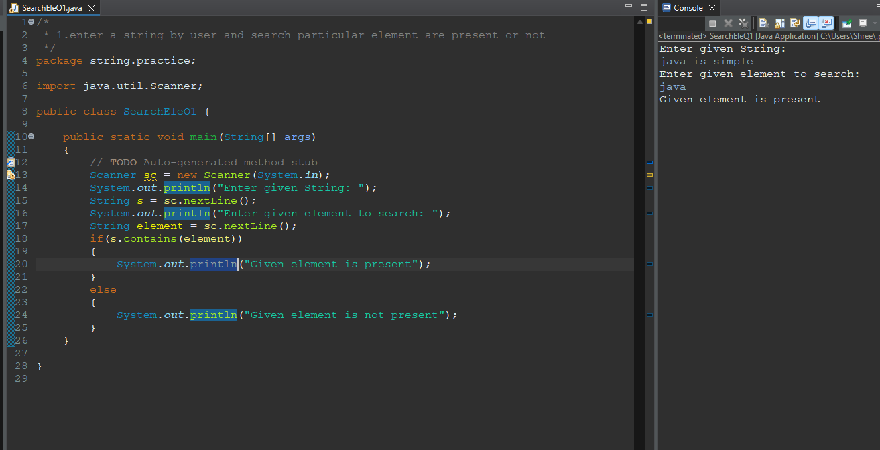

2. enter a string by user and convert it in lower case

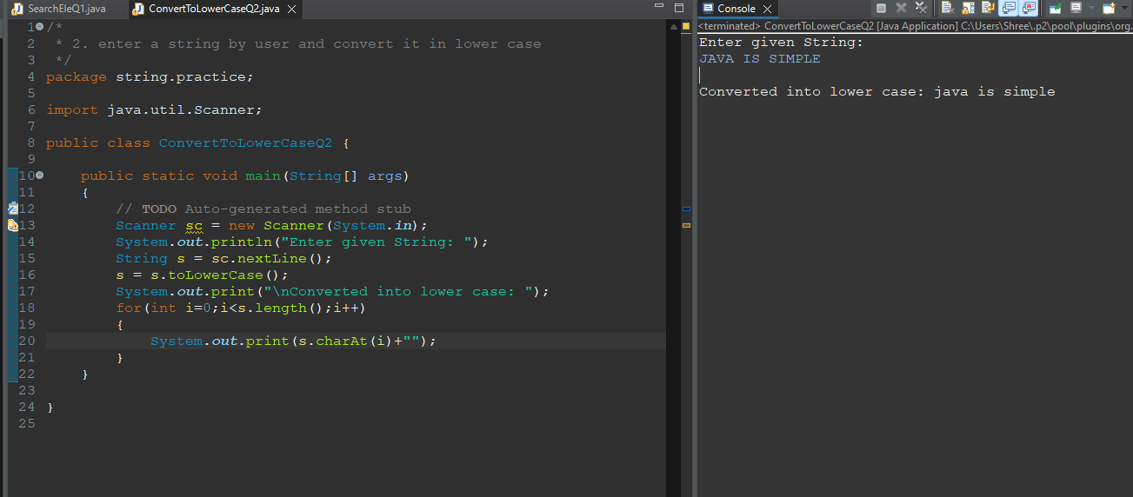

3.enter a string by user and convert it in upper case

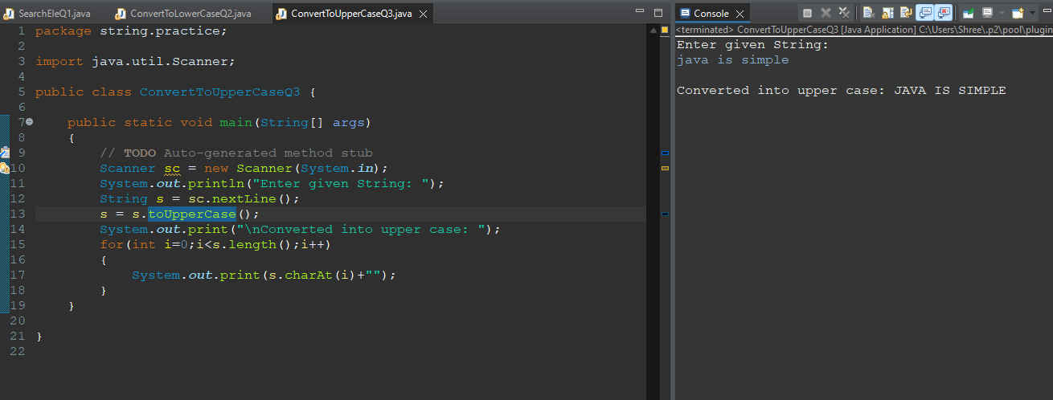

4.enter a string by user and search particular character and print its no

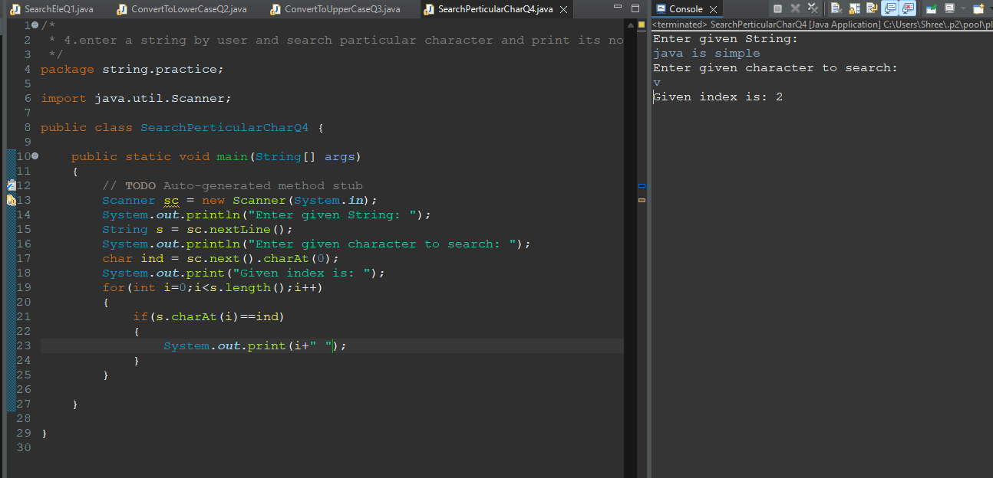

5.enter a string and count the no of vowel and consonent.

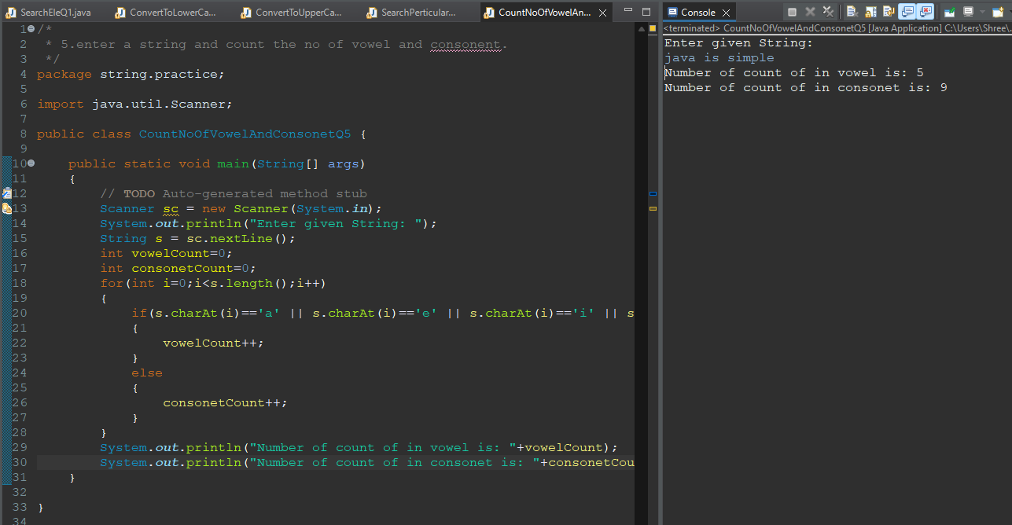

6.Write a Java program to concatenate two strings.

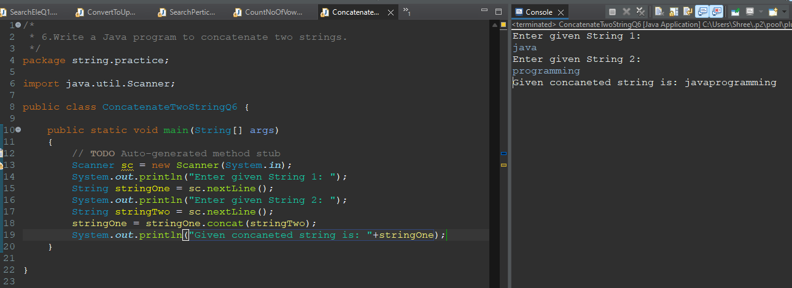

7.Write a Java program to compare two strings using equalignore case.

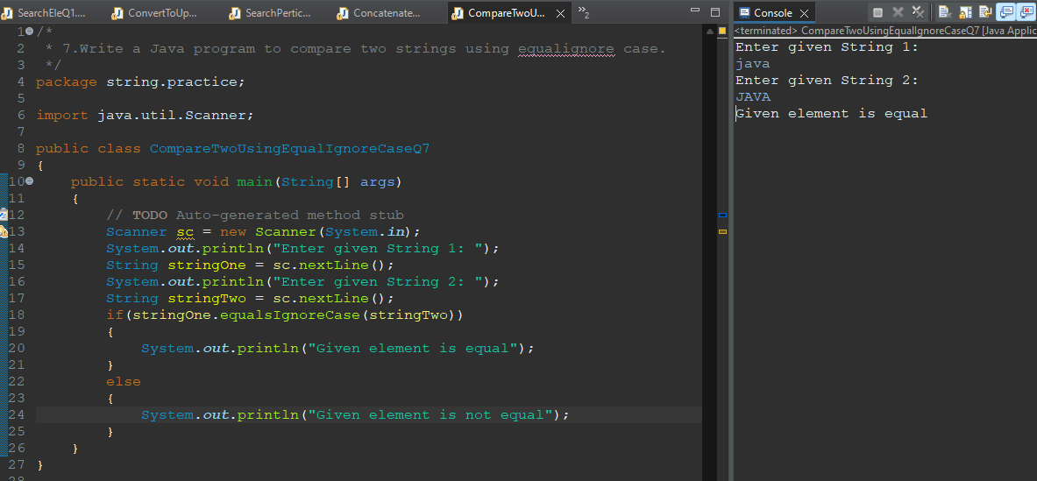

8.Wap enter a string and the character present at even and odd position individually.

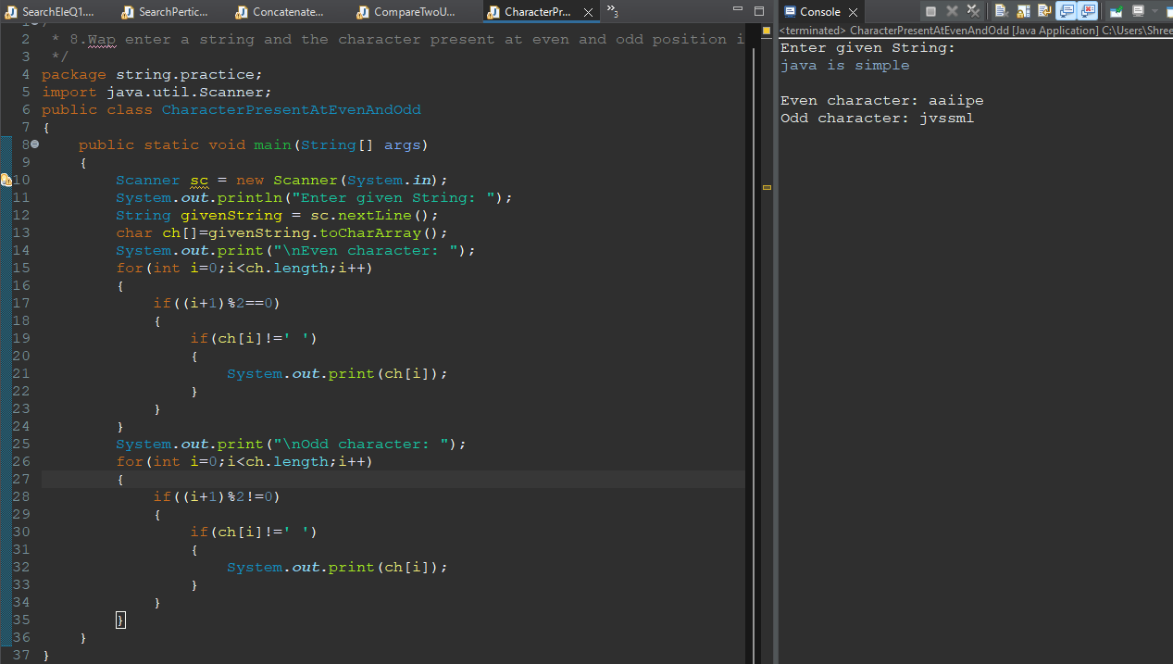

9.Write a Java program to find the occurence of first word in the string.

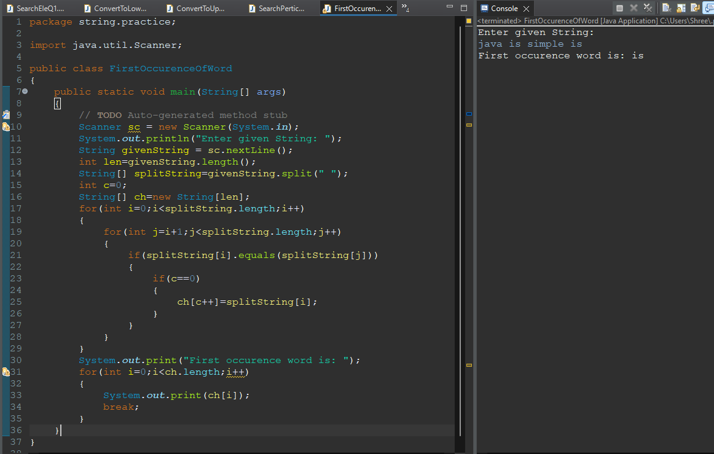

10.Wap to show an example of method overloading and method overriding. using string.

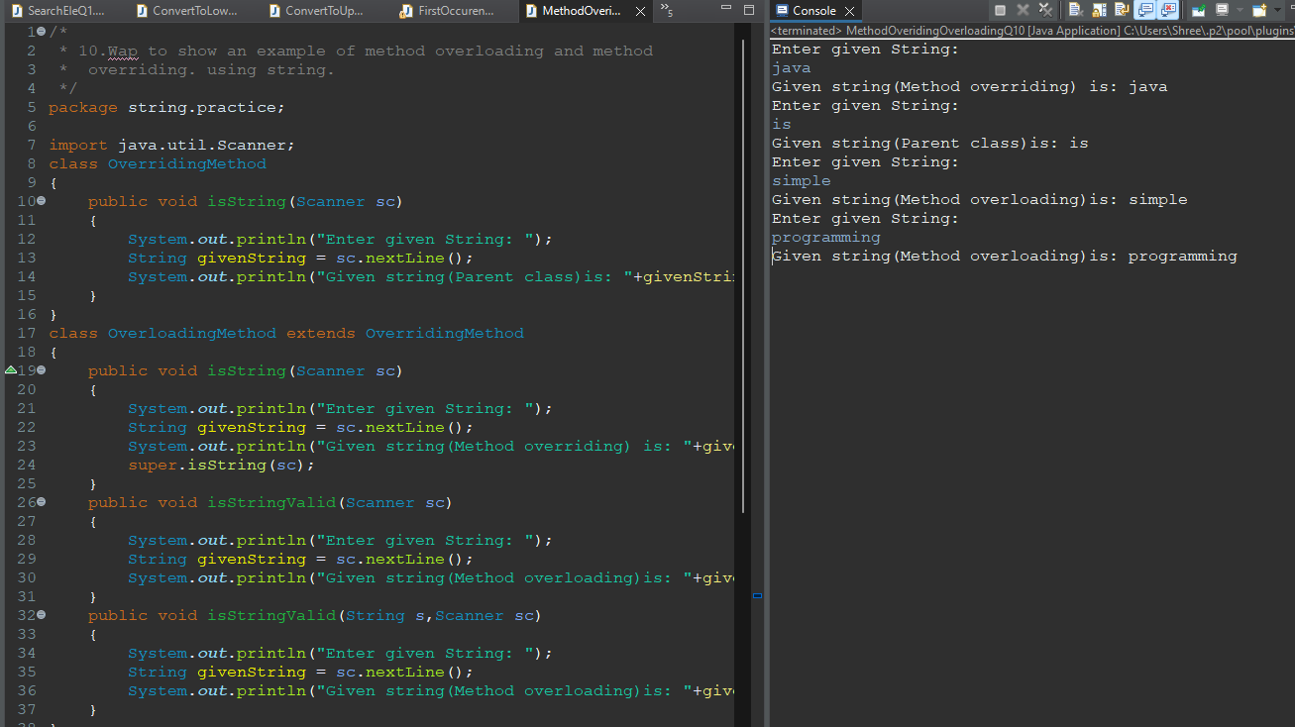

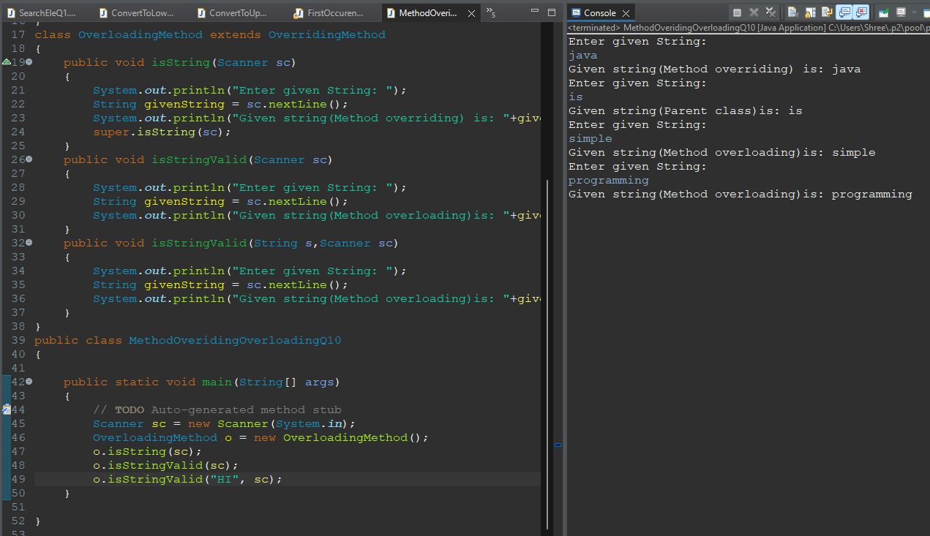

11.Wap enter a string and remove all duplicate character using class and object.

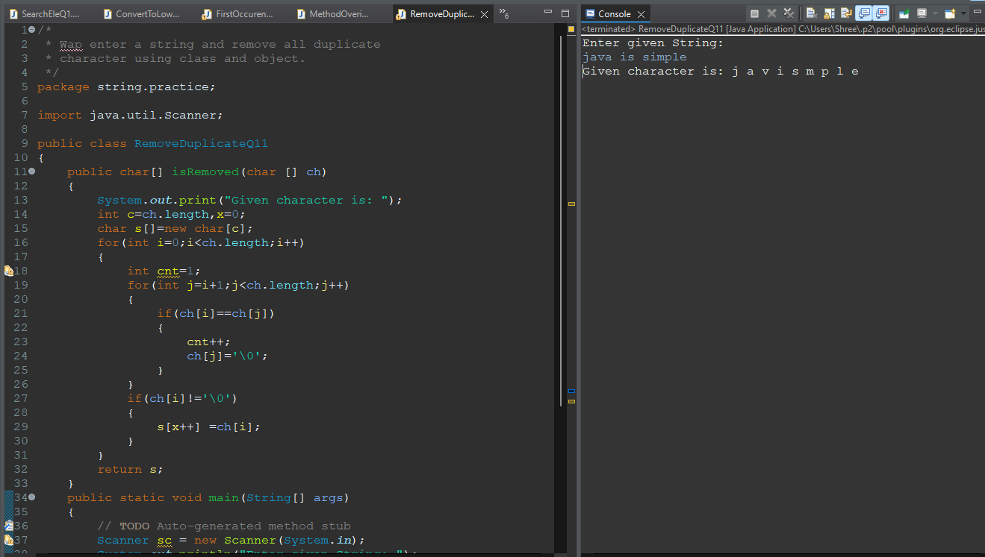

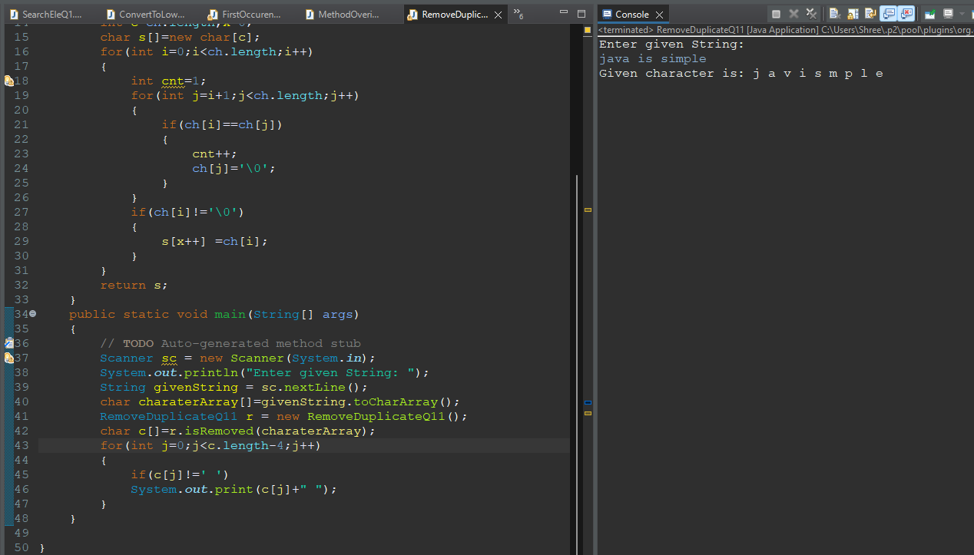

12.Wap to show 1-1 example of these string methods:

charAt

trim

CompareTo

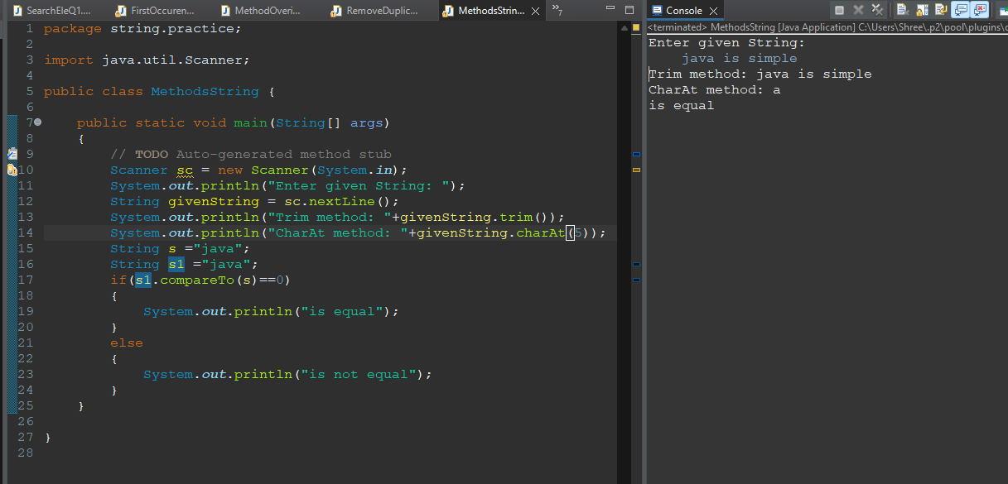

CompareToignore



Concat



Contains



Q13.Write a Java program to find reverse of a string using class and object.

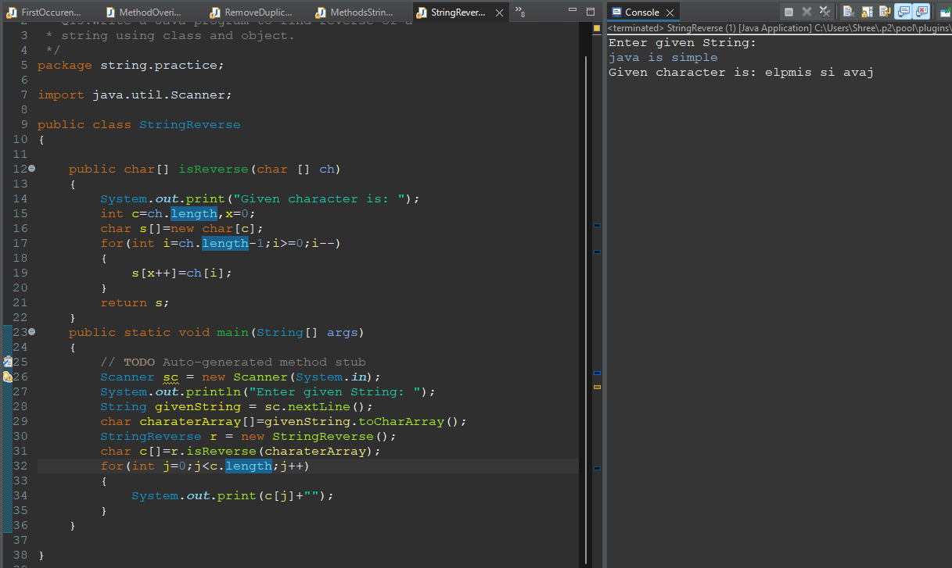

Q14.Wap enter a string and and remove first character and print final string.

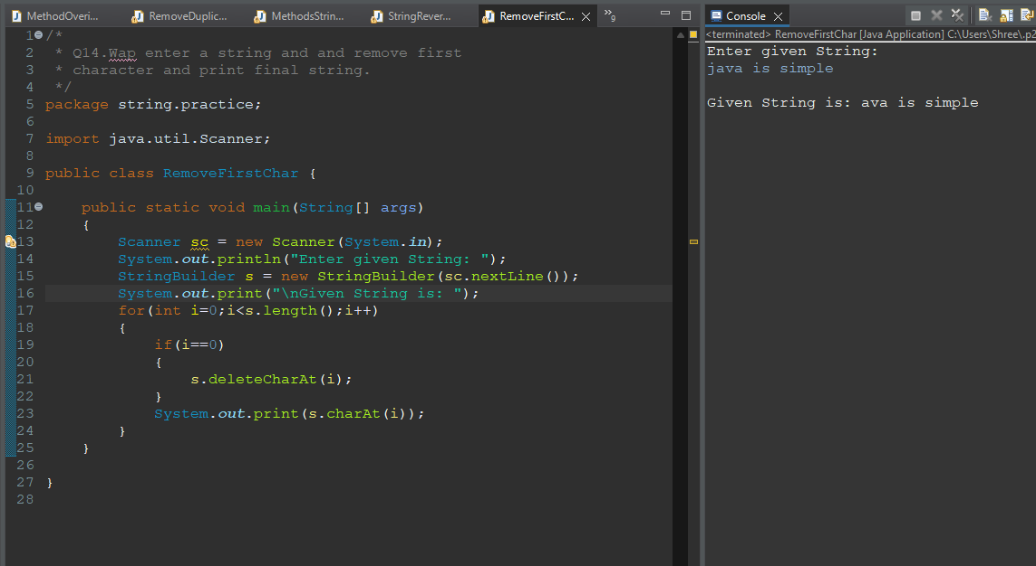

Q15.Wap enter a string and and remove last character and print final string.

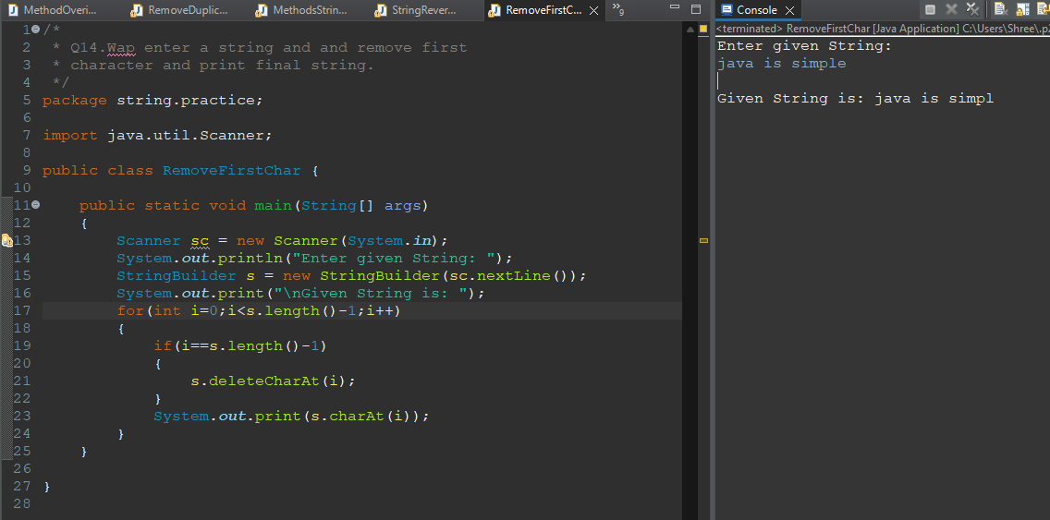

Q16.Wap enter a string and print substring of any given range.

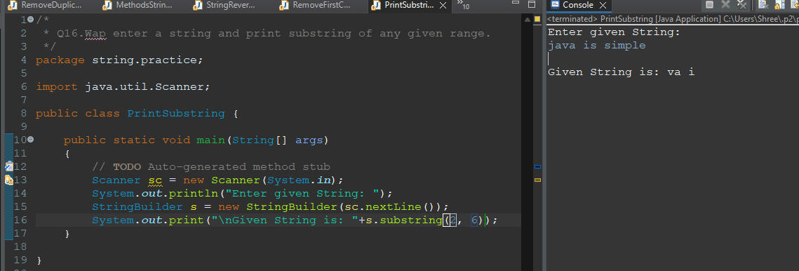

Q17.Wap enter a string and check any particular string are present in it or not using contains().



Q18.Wap enter a string and use endwith() and startwith() method.

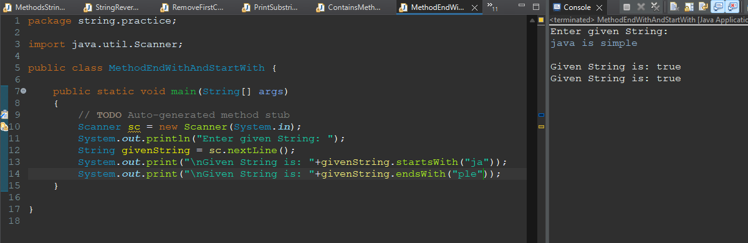

Q19.Write a Java program to find first occurrence of a character in a given string.



Q20.Wap enter a string and find the count of white space.

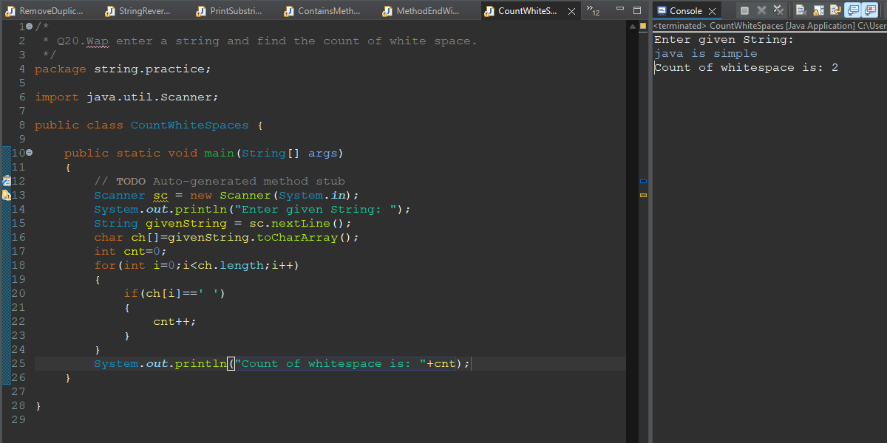

Q21.Wap enter a string and print all duplicate character.

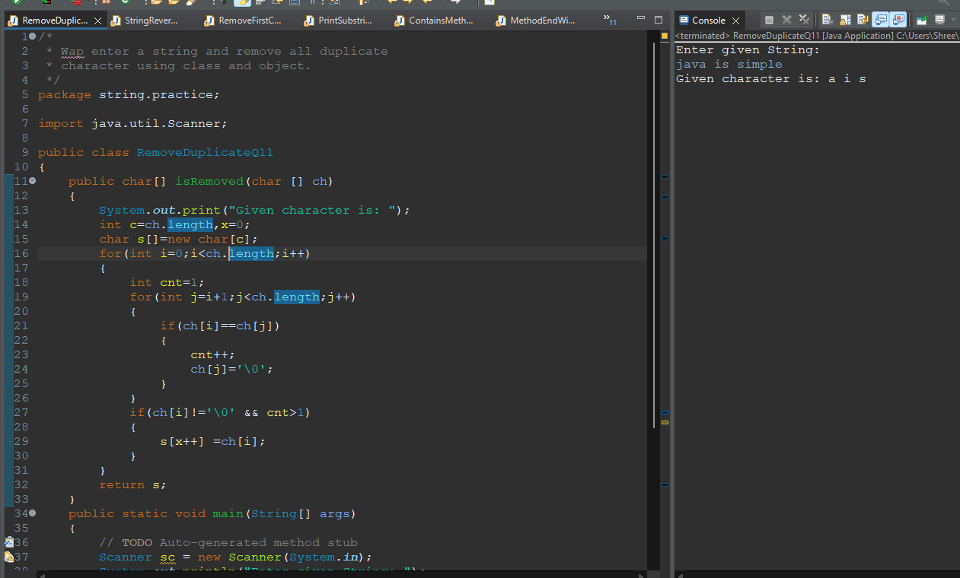

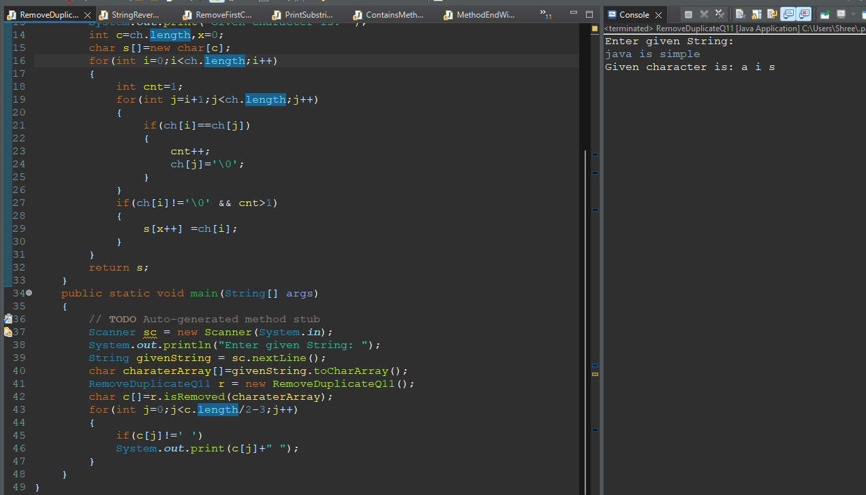

Assignment3:

Q1.Wap enter a string and print it in a reverse order word by word.

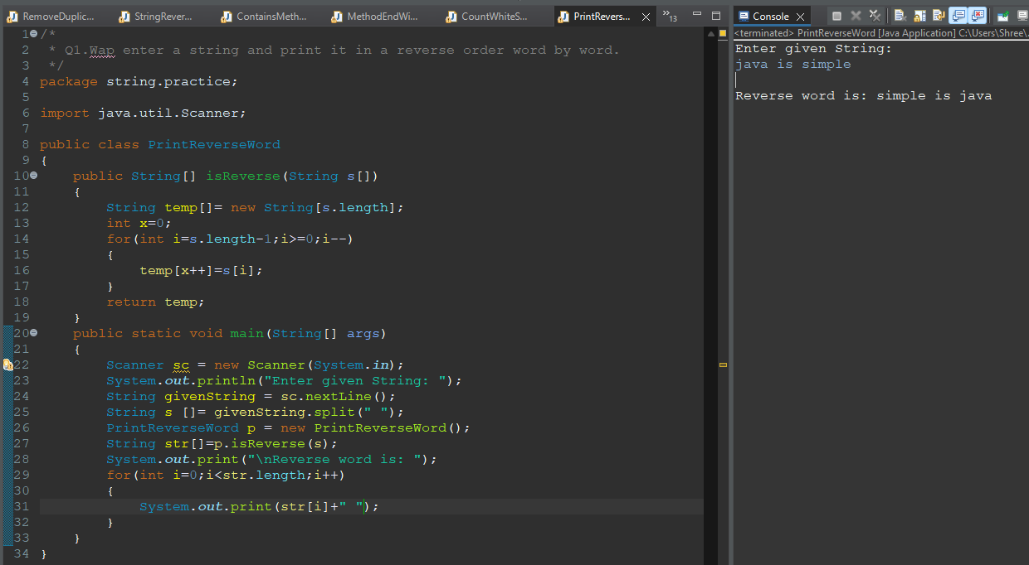

Q2.Wap enter a string and find the count of word and character(excluding space).

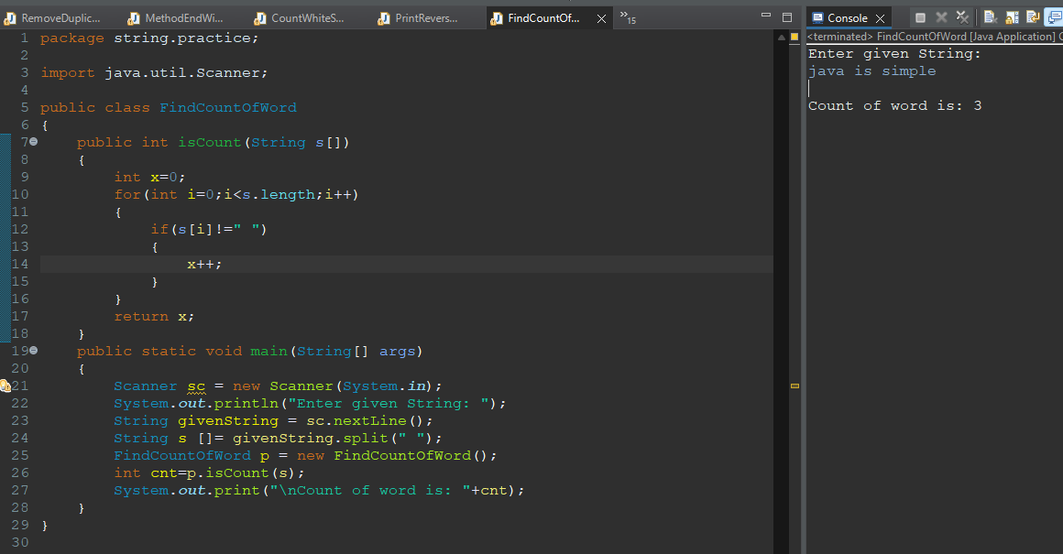

Q3.Wap input a string and print only those word which first character is vowel.

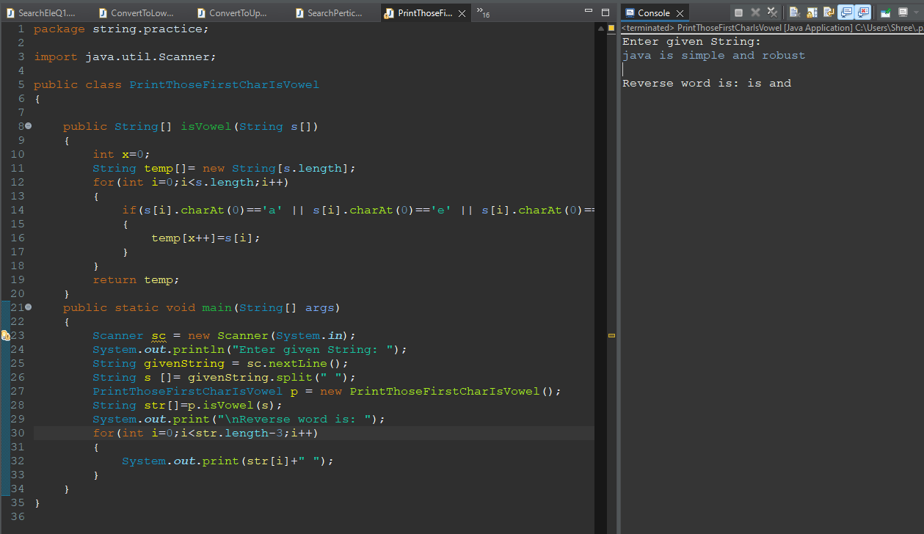

Q4.Wap enter a string and sort each word of string in accending and decending order by the length of each word.

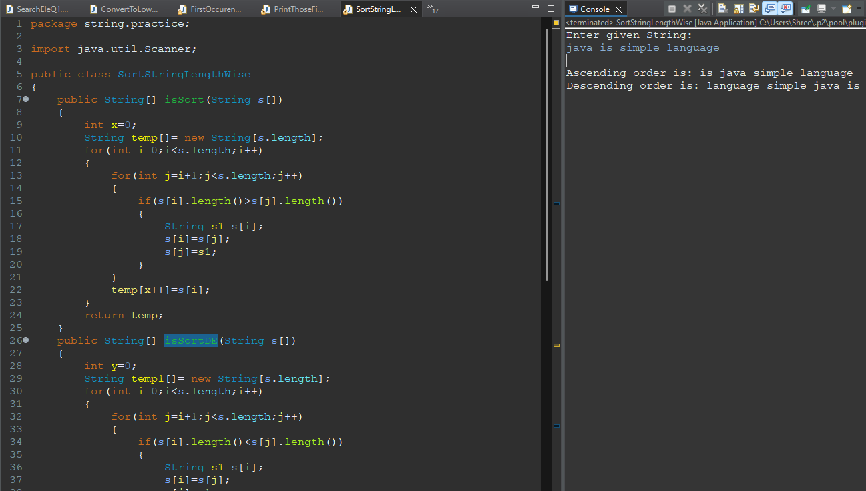

Q5.Wap enter a string in lowercase now you have to convert every first character of the word in upper case.

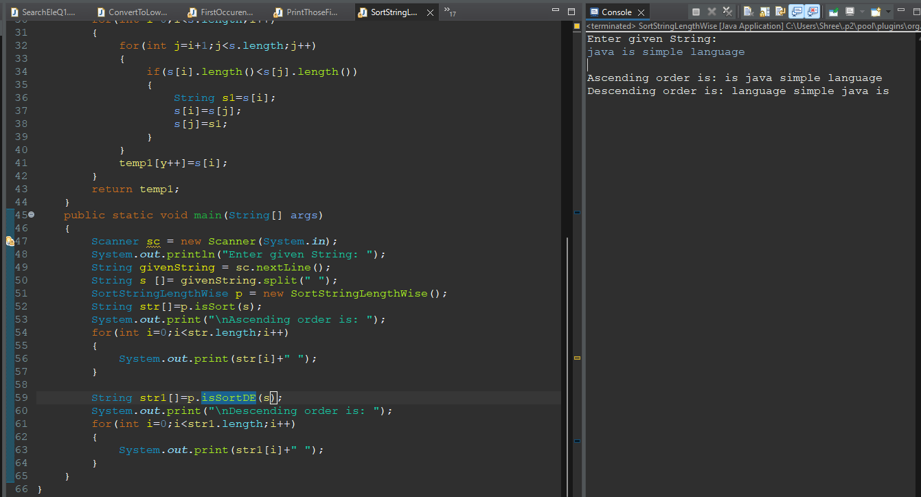



Q6.Wap enter a string and print first non repeating character using class and object.

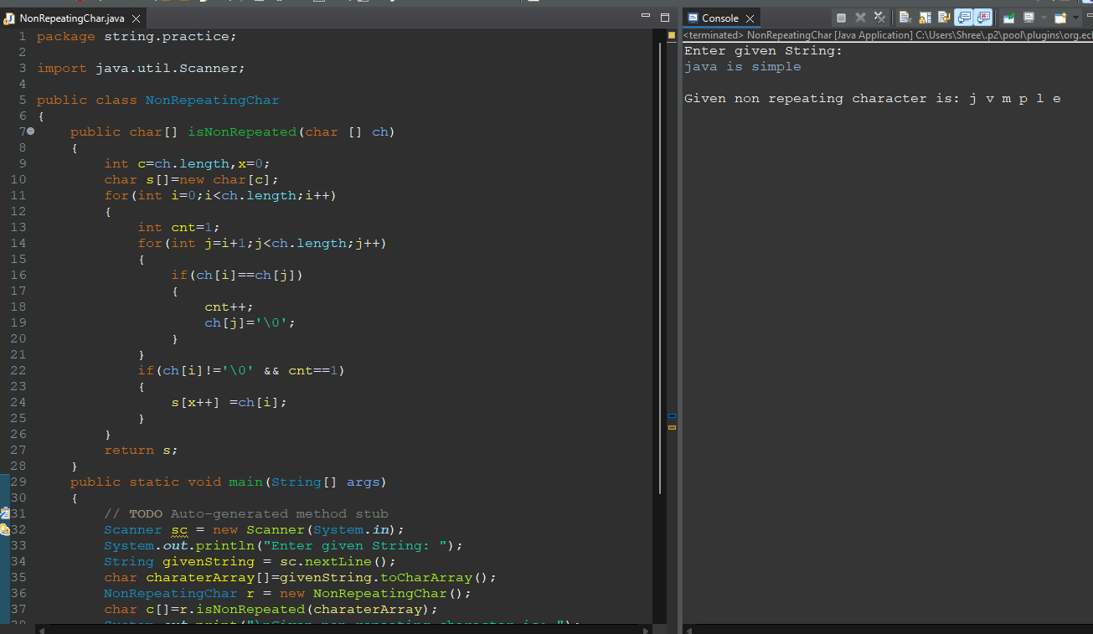

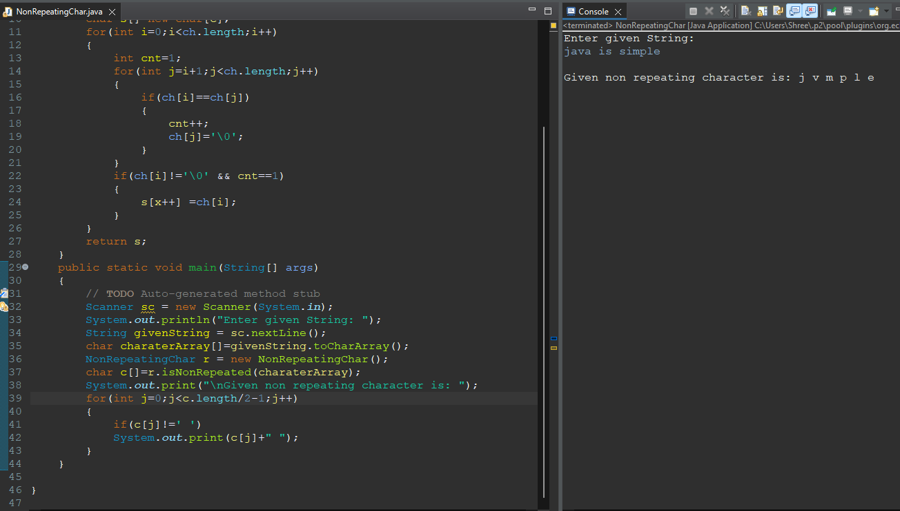

Q7.Wap enter a string and check it is anagram or not constructor and using class and object.

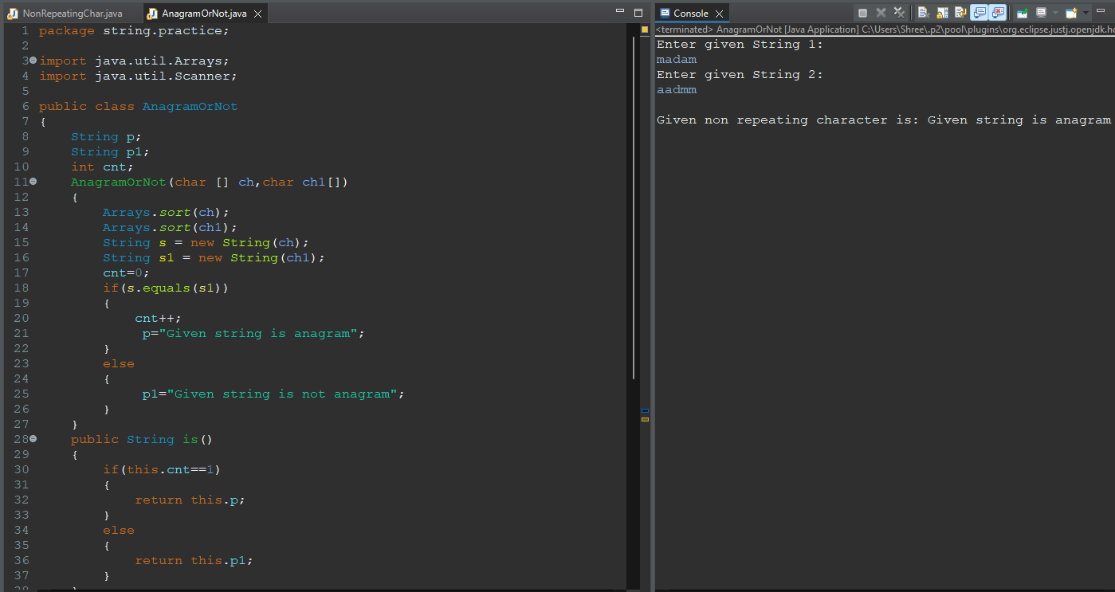

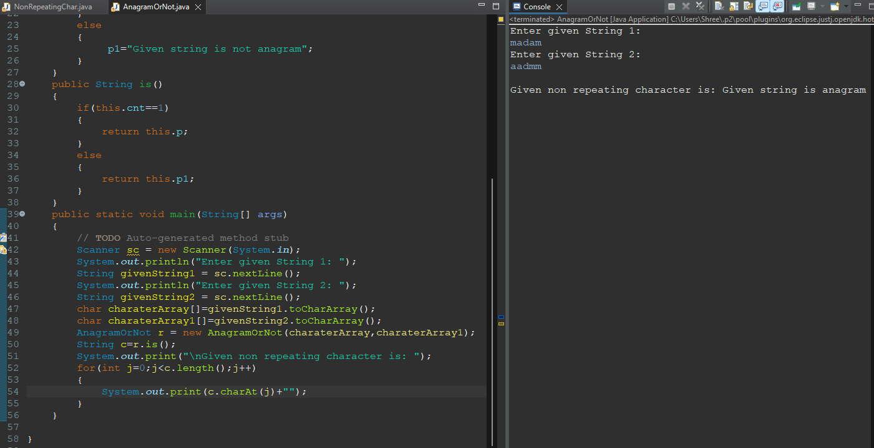

Q8.Wap enter a string and print most repeated character in string.

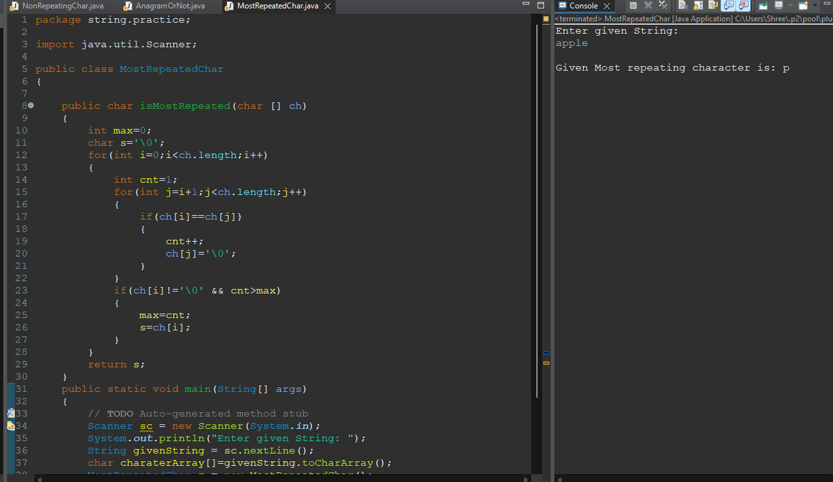

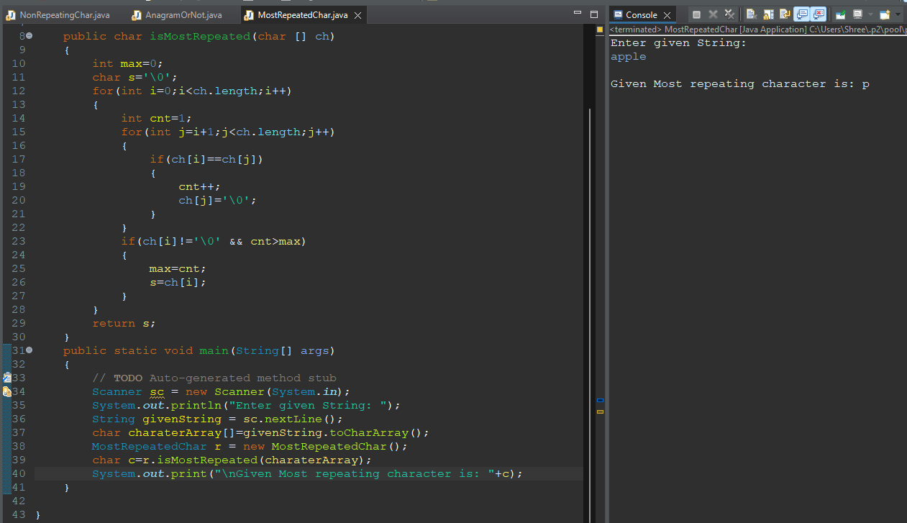

Q9. Write a Java program to create a new string from a given string swapping the last two

characters of the given string. The length of the given string must be two or more.

Sample Output:

The given strings is: string

The string after swap last two characters are: strign

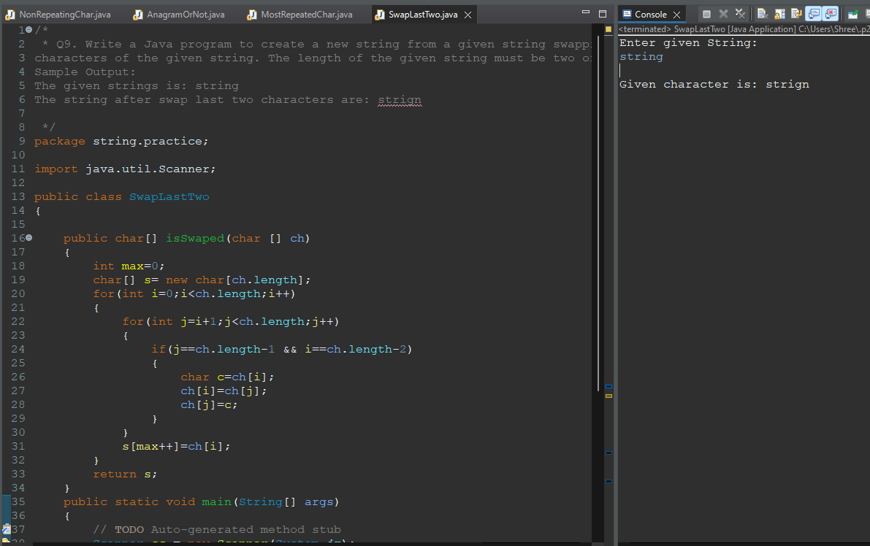

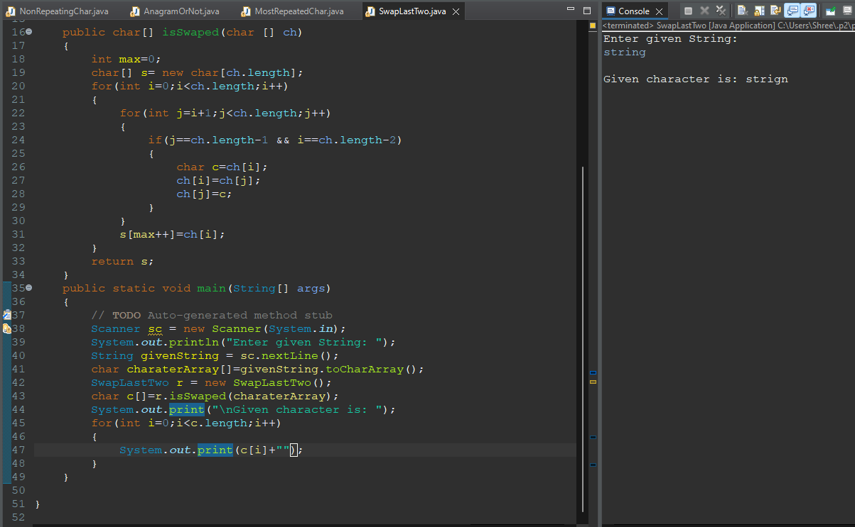

Q10. Write a Java program to read a given string and if the first or last characters are same

return the string without those characters otherwise return the string unchanged

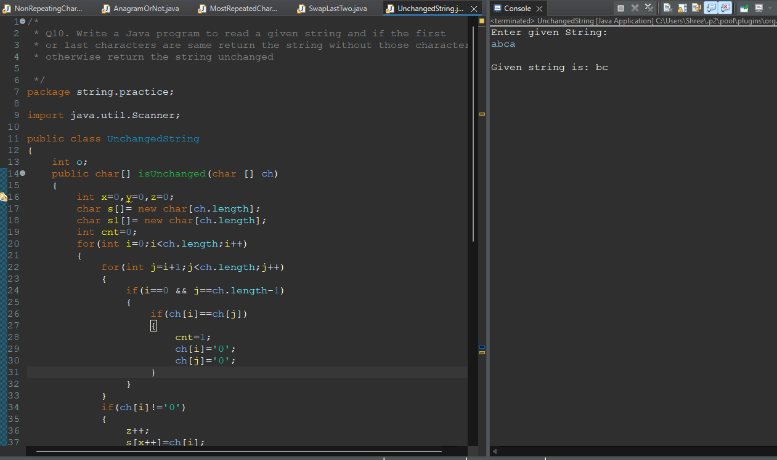

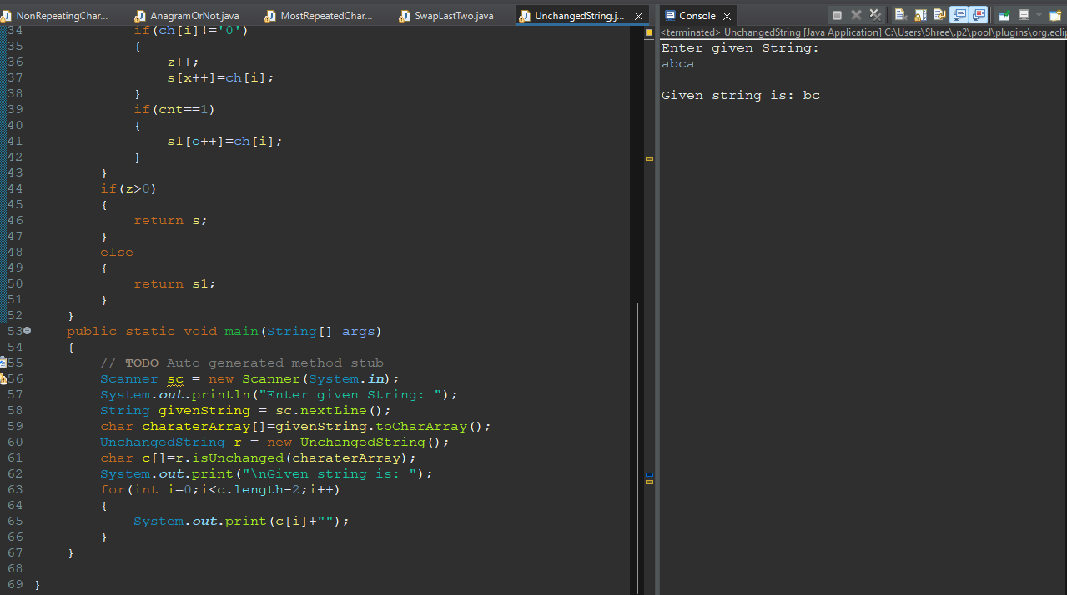

Q11.Wap enter a string and find the percentage of uppercase, lowercase, digits and special characters in a string.

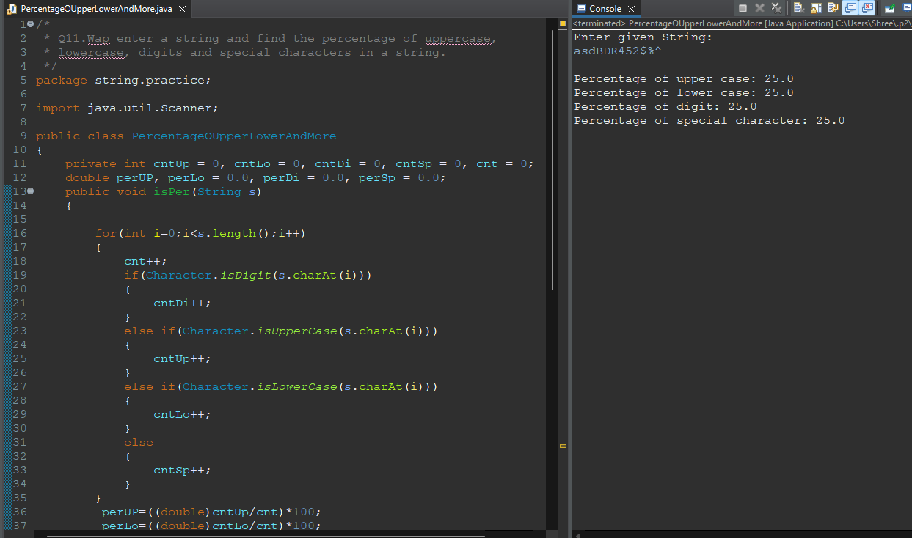

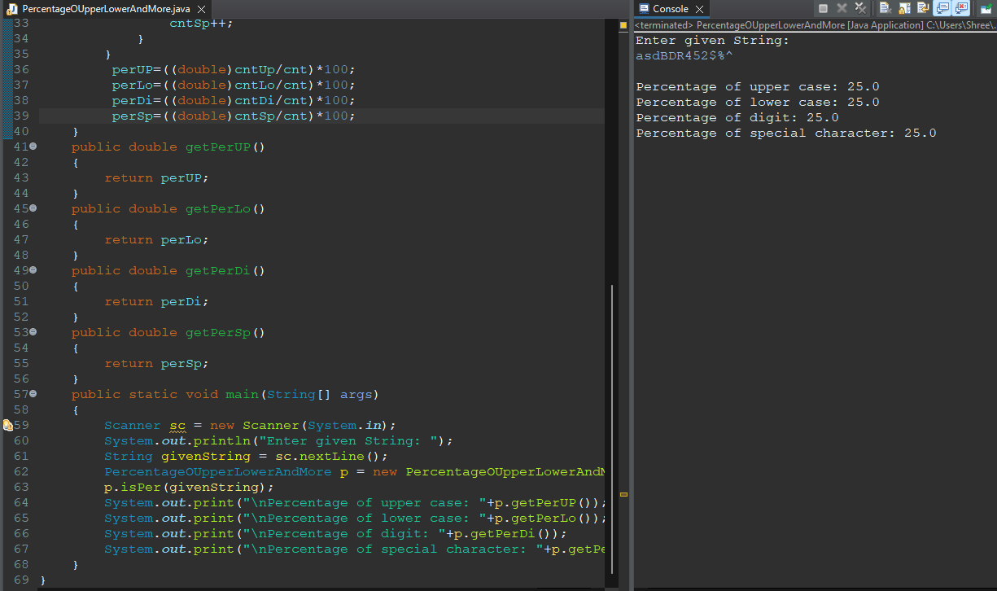

Q12. Write a Java program to read a given string and if the first or last characters are same

return the string without those characters otherwise return the string unchanged.

Sample Output:

The given strings is: testcricket

The new string is: estcricke

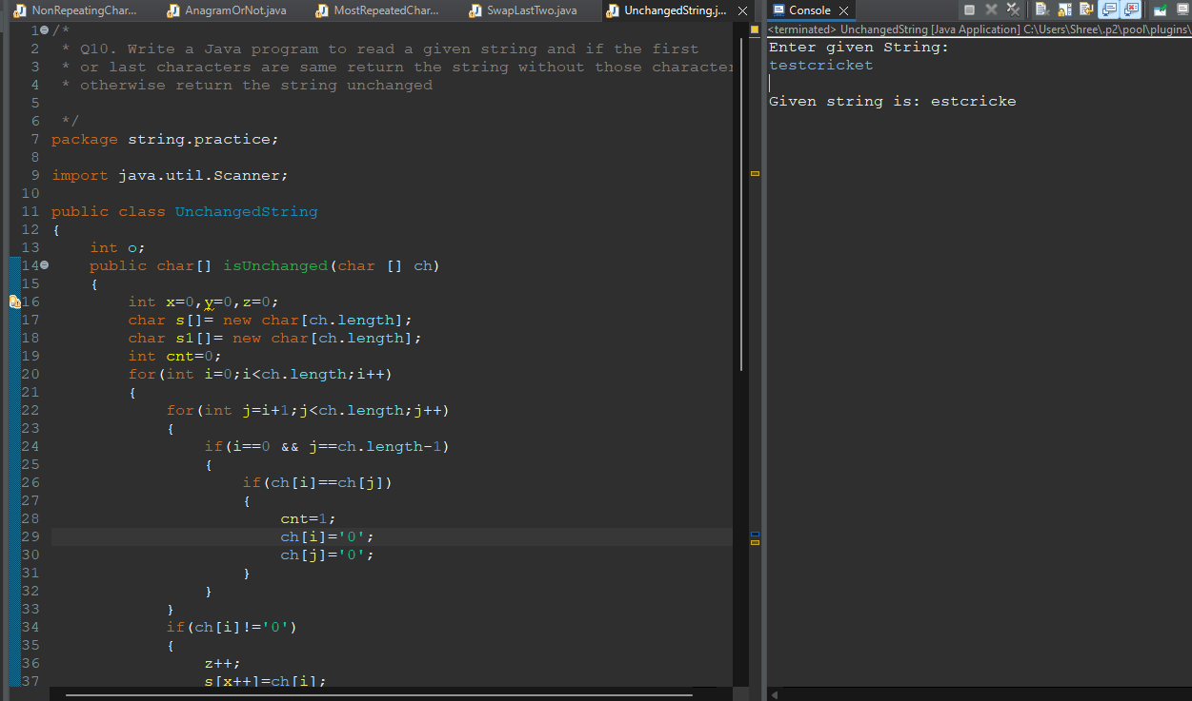

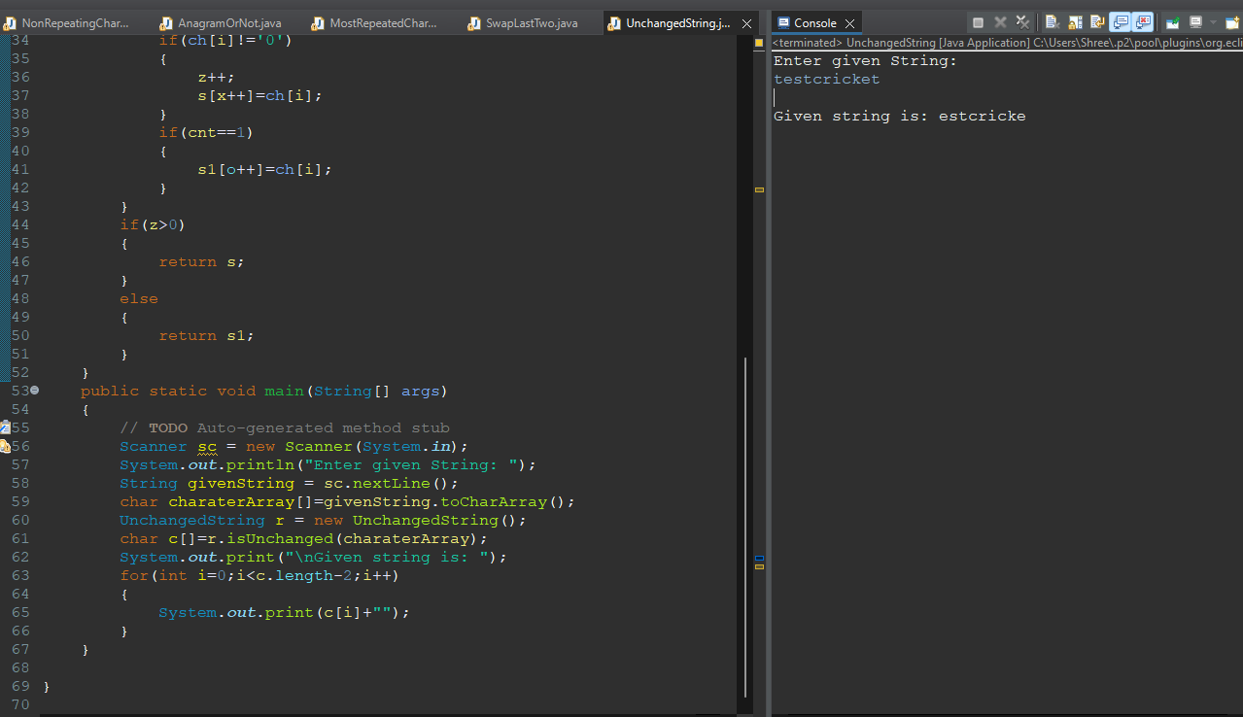

Q13. Write a Java program to create a new string repeating every character twice of a

given string.

Sample Output:

The given string is: welcome

The new string is: wweellccoomme

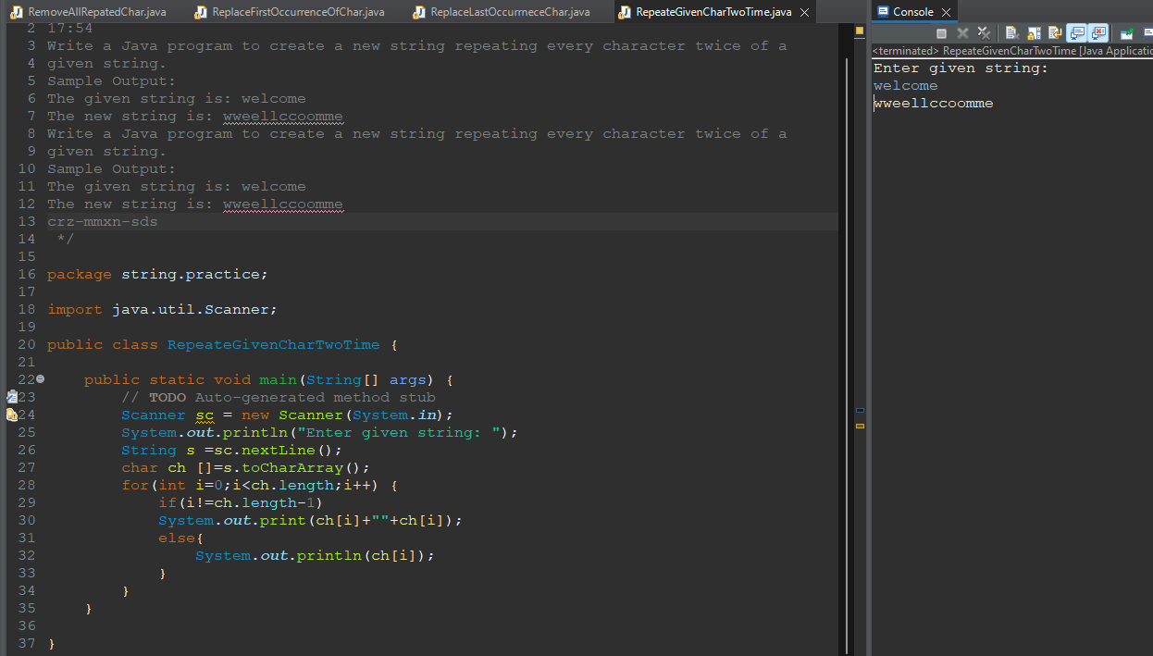

Assignment: 4

Q1.Write a Java program to find last occurrence of a character in a given string.

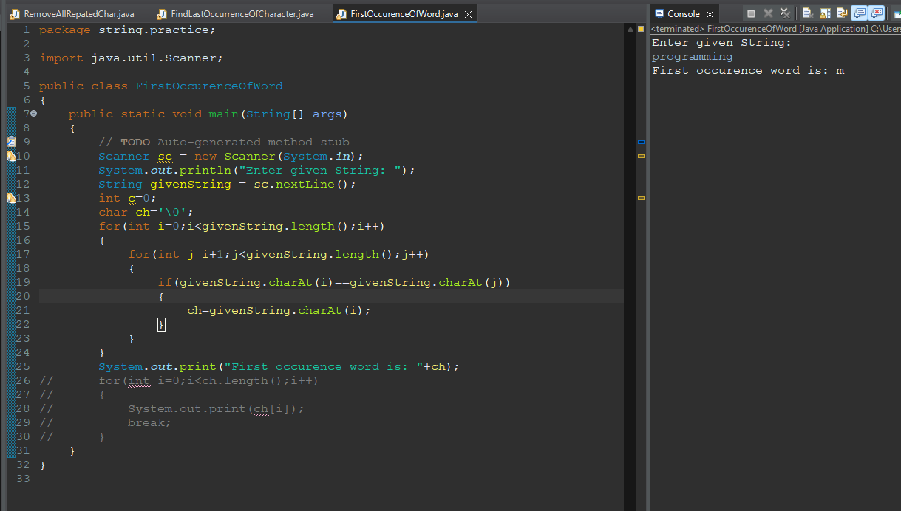

Q2.Write a Java program to find highest frequency character in a string.

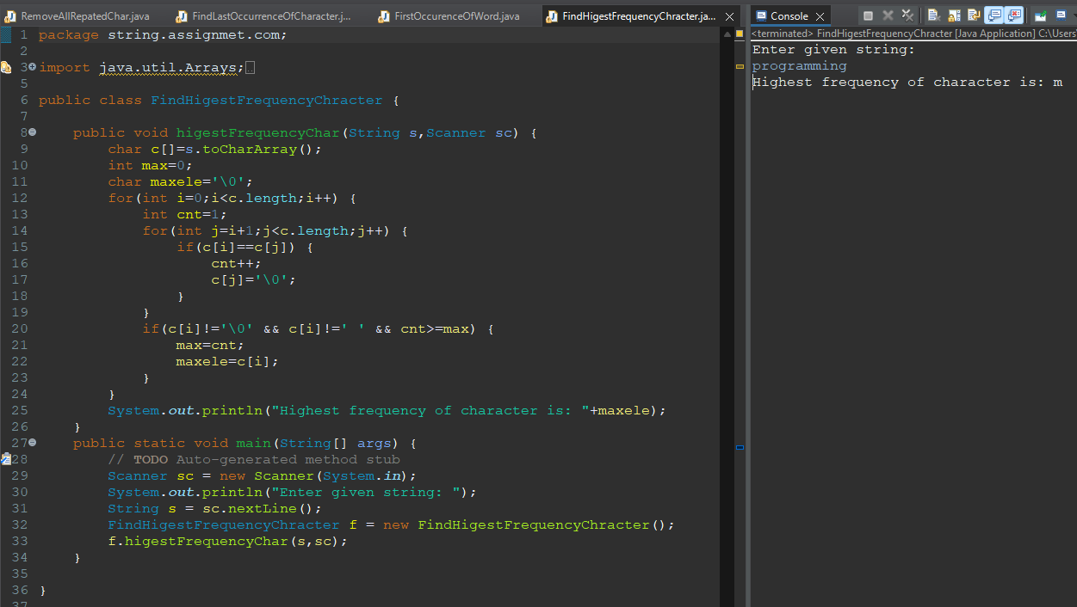

Q3.Write a Java program to find lowest frequency character in a string.

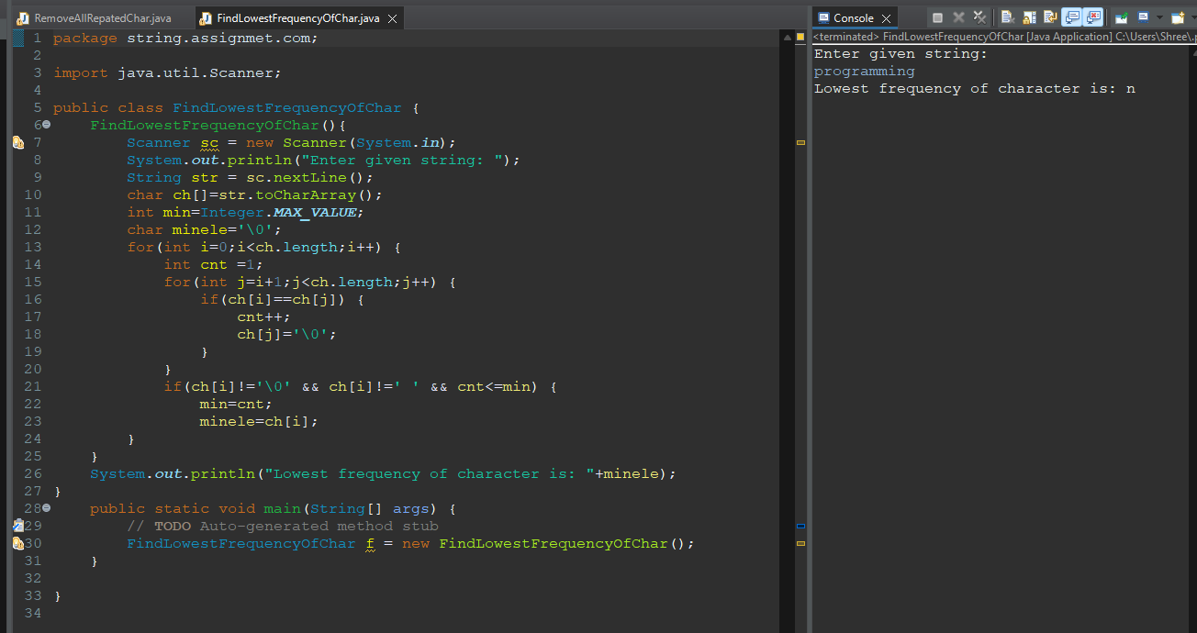

Q4.Write a Java program to count frequency of each character in a string.

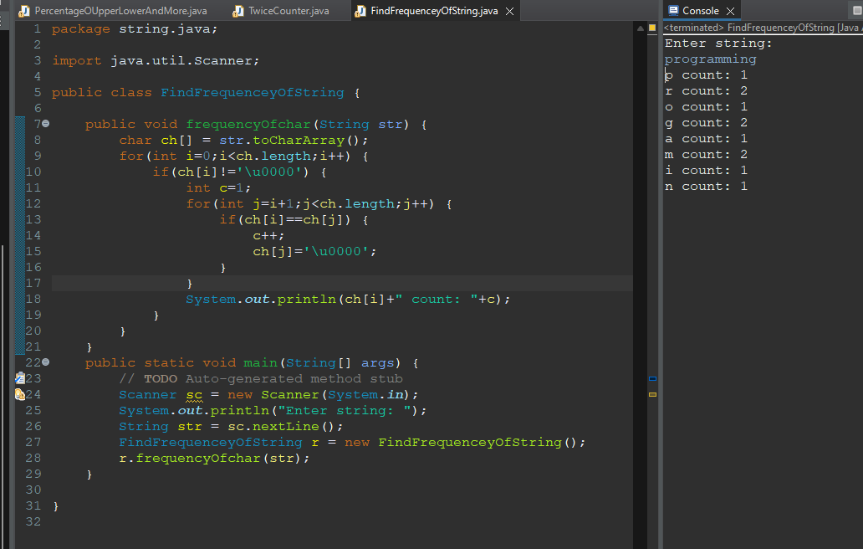

Q5.Write a Java program to remove first occurrence of a character from string.

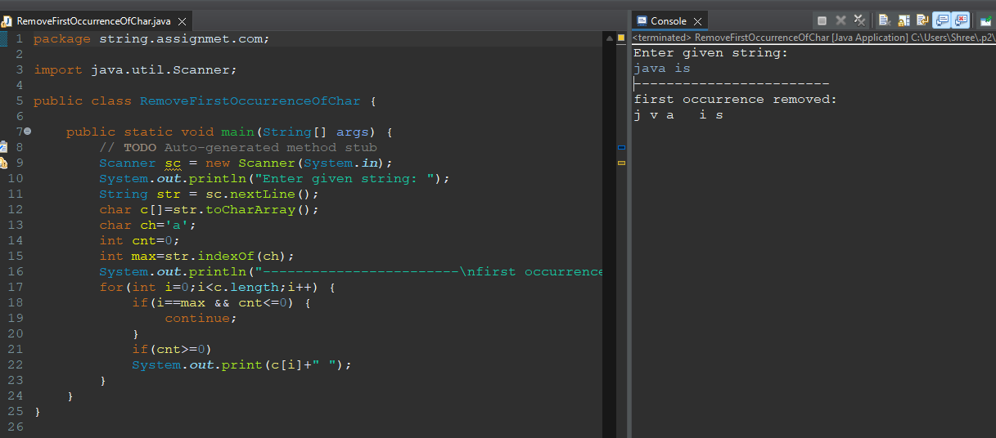

Q6.Write a Java program to remove last occurrence of a character from string.

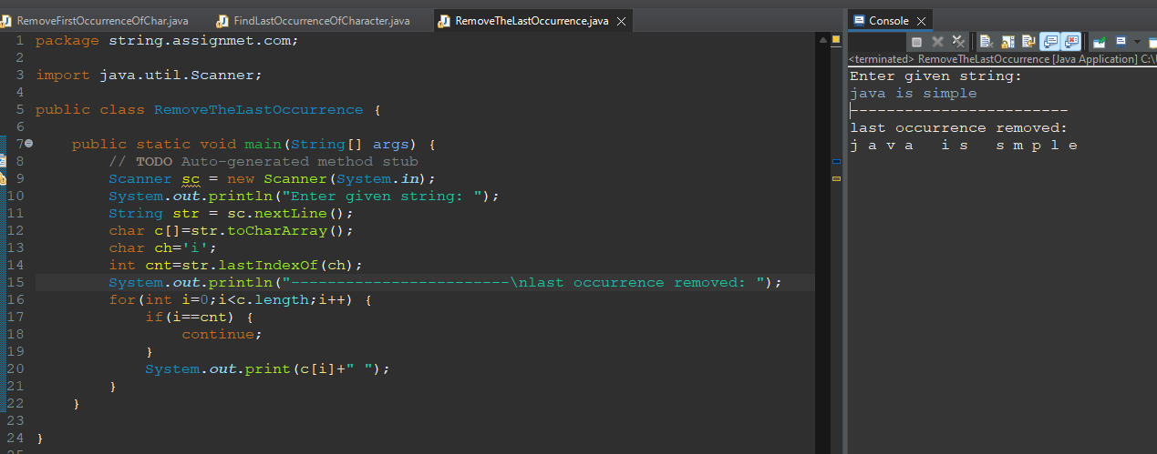

Q7.Write a Java program to remove all repeated characters from a given string.

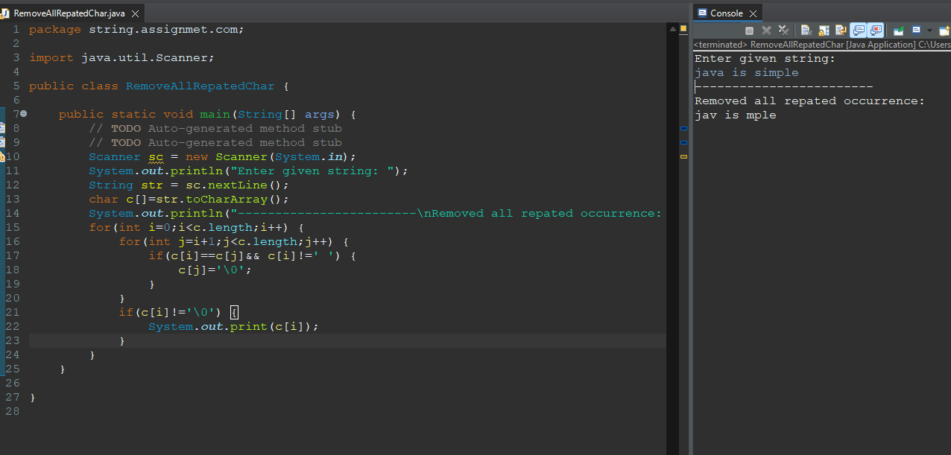

Q8.Write a Java program to replace first occurrence of a character with another in a string.

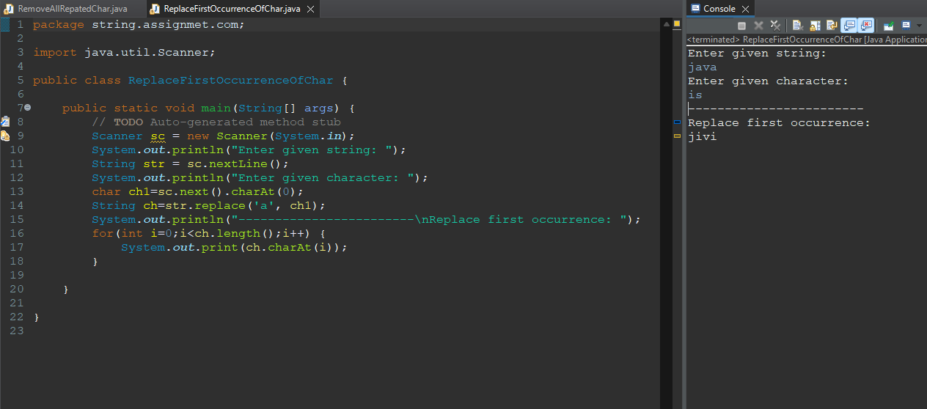

Q9.Write a Java program to replace last occurrence of a character with another in a string.

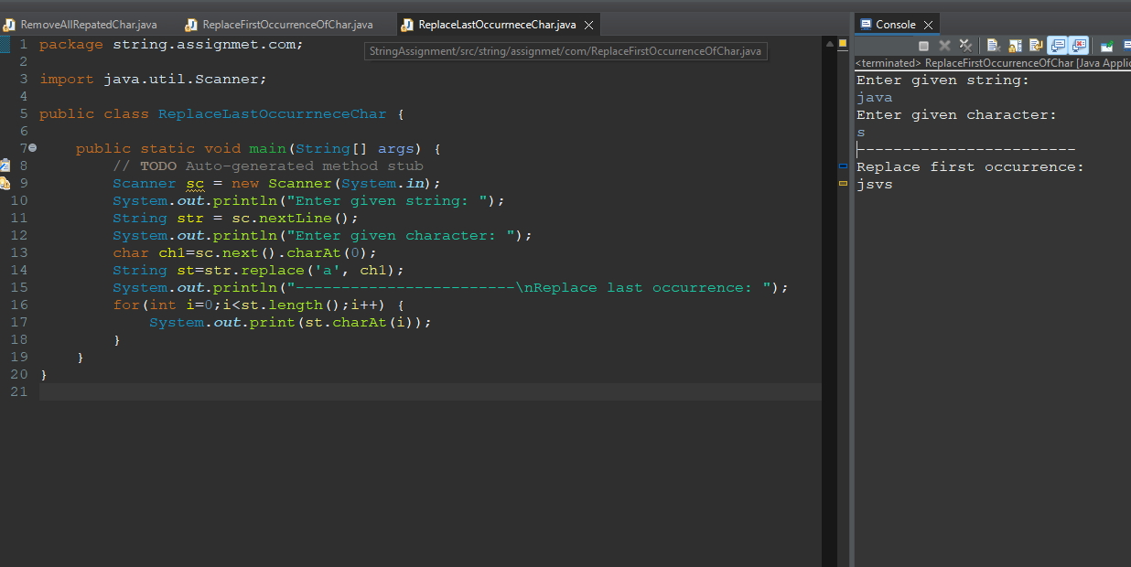

Q10.Write a Java program to find total number of alphabets, digits or special character in a string.

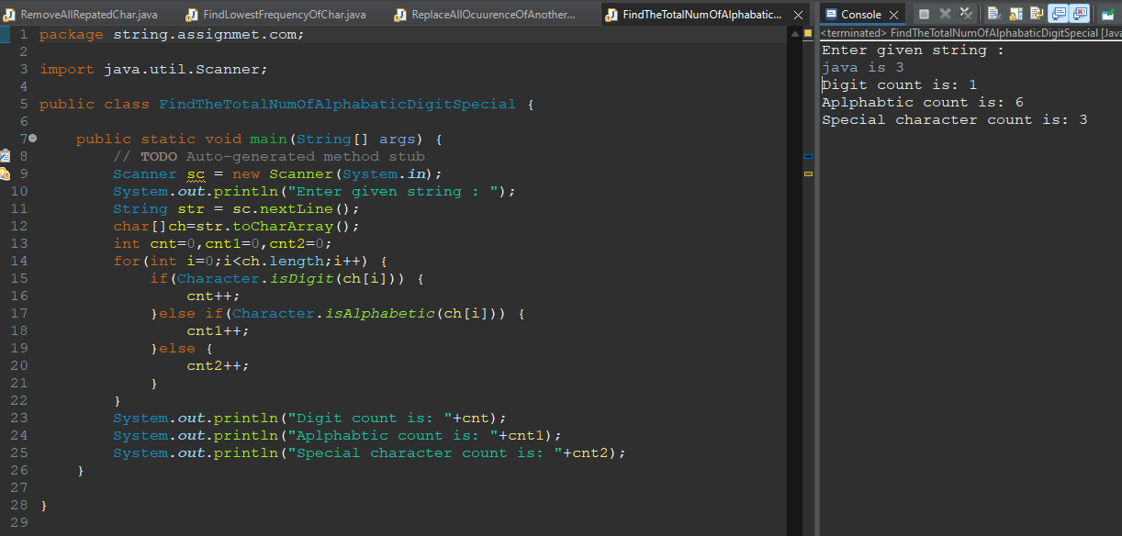

Assignment:5

Q1.Wap enter a string and print it in a reverse order word by word.



Q2.Wap enter a string and find the count of word and character(excluding space).



Q3.Wap input a string and print only those word which first character is vowel.



Q4.Wap enter a string and sort each word of string in accending and decending order by the length of each word.



Q5.Wap enter a string in lowercase now you have to convert every first character of the word in upper case.





Q6.Wap enter a string and print first non repeating character using class and object.





Q7.Wap enter a string and check it is anagram or not constructor and using class and object.





Q8.Wap enter a string and print most repeated character in string.





Q9. Write a Java program to create a new string from a given string swapping the last two

characters of the given string. The length of the given string must be two or more.

Sample Output:

The given strings is: string

The string after swap last two characters are: strign





Q10. Write a Java program to read a given string and if the first or last characters are same

return the string without those characters otherwise return the string unchanged





Q11.Wap enter a string and find the percentage of uppercase, lowercase, digits and special characters in a string.





Q12. Write a Java program to read a given string and if the first or last characters are same

return the string without those characters otherwise return the string unchanged.

Sample Output:

The given strings is: testcricket

The new string is: estcricke





Q13. Write a Java program to create a new string repeating every character twice of a

given string.

Sample Output:

The given string is: welcome

The new string is: wweellccoomme

